Weather Report Project Description

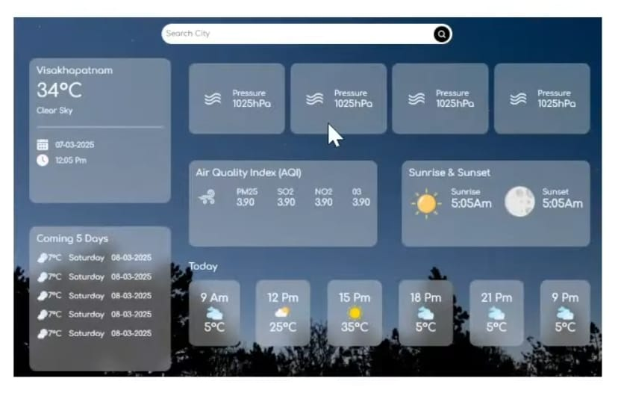

Bootstrap :- Bootstrap is a free and open-source front-end framework used to build responsive and mobile-first websites. It was originally developed by Twitter engineers Mark Otto and Jacob Thornton and has become one of the most popular tools for web developers.
Property of bootstrap
Include Bootstrap’s CSS and JS. Place the <link> tag in the <head> for our CSS, and the <script> tag for our JavaScript bundle (including Popper for positioning dropdowns, popovers, and tooltips) before the closing </body>. Learn more about our CDN links.
<!doctype html>
<html lang="en">
<head>
<meta charset="utf-8">
<meta name="viewport" content="width=device-width, initial-scale=1">
<title>Bootstrap demo</title>
<link href="https://cdn.jsdelivr.net/npm/bootstrap@5.3.7/dist/css/bootstrap.min.css" rel="stylesheet" integrity="sha384-LN+7fdVzj6u52u30Kp6M/trliBMCMKTyK833zpbD+pXdCLuTusPj697FH4R/5mcr" crossorigin="anonymous">
</head>
<body>
<h1>Hello, world!</h1>
<script src="https://cdn.jsdelivr.net/npm/bootstrap@5.3.7/dist/js/bootstrap.bundle.min.js" integrity="sha384-ndDqU0Gzau9qJ1lfW4pNLlhNTkCfHzAVBReH9diLvGRem5+R9g2FzA8ZGN954O5Q" crossorigin="anonymous"></script>
</body>
</html>
You can also include Popper and our JS separately. If you don’t plan to use dropdowns, popovers, or tooltips, save some kilobytes by not including Popper.
<script src="https://cdn.jsdelivr.net/npm/@popperjs/core@2.11.8/dist/umd/popper.min.js" integrity="sha384-I7E8VVD/ismYTF4hNIPjVp/Zjvgyol6VFvRkX/vR+Vc4jQkC+hVqc2pM8ODewa9r" crossorigin="anonymous"></script>
<script src="https://cdn.jsdelivr.net/npm/bootstrap@5.3.7/dist/js/bootstrap.min.js" integrity="sha384-7qAoOXltbVP82dhxHAUje59V5r2YsVfBafyUDxEdApLPmcdhBPg1DKg1ERo0BZlK" crossorigin="anonymous"></script>

